# **📘 Day 1 – Welcome to the 30 Days of PostgreSQL 🚀**

### **Kickstart Your Journey into the World of Databases 🐘**

## What is SQL ?

SQL (Structured Query Language) is a programming language used to interact with databases. It is the standard language for querying, inserting, updating, and managing data stored in relational databases.

## Why we use SQL?

1. Simplifies working with large datasets.

2. Enables easy and efficient data management.

3. SQL is universal and works with most database systems (like PostgreSQL, MySQL, SQL Server)

### SQL used in following job roles of data field

SQL is an essential skill in many data-related job roles. Here's how SQL is used in some common job roles within the data field:

### **1. Data Analyst 📊**

* **Use of SQL:** Extracting and querying data from databases to generate insights, create reports, and visualize data.
* **Tasks:**
  + Writing SQL queries to clean and filter large datasets.
  + Using SQL for aggregations, joins, and summarizations.
  + Automating report generation and creating dashboards using tools like Power BI or Tableau connected to SQL databases.

### **2. Data Scientist 🧑‍💻🔬**

* **Use of SQL:** SQL is used to access, manipulate, and prepare data for analysis and model building.
* **Tasks:**
  + Extracting data from relational databases.
  + Cleaning and preprocessing data.
  + Performing complex queries to explore and analyze data for predictive modeling.

### **3. Database Administrator (DBA) 🛠️**

* **Use of SQL:** SQL is crucial for managing and optimizing databases.
* **Tasks:**
  + Creating, modifying, and maintaining database schemas.
  + Writing SQL queries for database performance tuning and optimization.
  + Ensuring data integrity and security through structured queries.

### **4. Business Intelligence (BI) Analyst 📈**

* **Use of SQL:** Analyzing business data and creating dashboards and reports to inform decision-making.
* **Tasks:**
  + Writing complex SQL queries to extract insights from business data.
  + Creating views, stored procedures, and scripts for reporting.
  + Using SQL in conjunction with BI tools to create interactive dashboards.

### **5. Data Engineer 💻🔧**

* **Use of SQL:** SQL is used to design and implement data pipelines and ETL processes.
* **Tasks:**
  + Writing SQL to extract, transform, and load (ETL) data into data warehouses.
  + Managing large-scale datasets and optimizing queries for performance.
  + Building and maintaining database systems for efficient data processing.

### **6. Data Architect 🏗️**

* **Use of SQL:** SQL is used to design database systems and ensure they meet business requirements.
* **Tasks:**
  + Designing complex database structures and relationships.
  + Writing SQL queries for data migration and integration.
  + Ensuring data storage and retrieval processes are efficient and scalable.

### **7. Machine Learning Engineer 🤖**

* **Use of SQL:** SQL is often used to query and retrieve data for training machine learning models.
* **Tasks:**
  + Querying relational databases to pull relevant features for model training.
  + Preprocessing and cleaning data using SQL before feeding it into machine learning algorithms.
  + Integrating databases with machine learning workflows.

### **8. Product Analyst 📊📈**

* **Use of SQL:** SQL is used to analyze product data to inform business decisions.
* **Tasks:**
  + Writing SQL queries to analyze user behavior, sales data, or product performance.
  + Conducting A/B testing analysis using SQL queries.
  + Reporting on product KPIs and creating data-driven strategies for product development.

### **9. Quantitative Analyst (Quant) 💹**

* **Use of SQL:** In finance, SQL is used to analyze financial data and perform statistical analysis.
* **Tasks:**
  + Writing SQL queries to extract and manipulate financial data for model validation.
  + Creating and managing large datasets used for quantitative analysis.
  + Using SQL for risk analysis and portfolio management.

### **10. ETL Developer 🔄**

* **Use of SQL:** SQL is crucial for building, managing, and maintaining ETL (Extract, Transform, Load) pipelines.
* **Tasks:**
  + Writing SQL queries to extract and load data into data warehouses.
  + Creating transformation rules for cleaning and reshaping data.
  + Ensuring smooth data flow and pipeline performance.

### Data

Data refers to raw facts or information that can be processed to generate meaningful insights. It can be numbers, text, images, or any other form of information.

### **Example:**

* **Numeric data:** Age of a person (e.g., 25)
* **Text data:** Name of a person (e.g., "Mohit Sharma")
* **Categorical data:** Gender (e.g., Male/Female)
* **Image data:** A picture file of a cat

### What is Database?

A database is collection of Data that can be easily access (Digitally)

A software to manage database is called DBMS (Database Management Software)

example

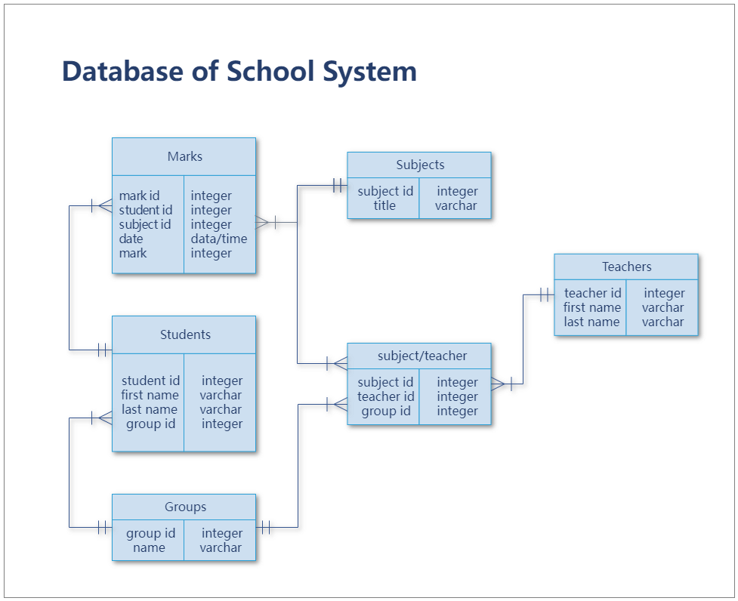

Table structure

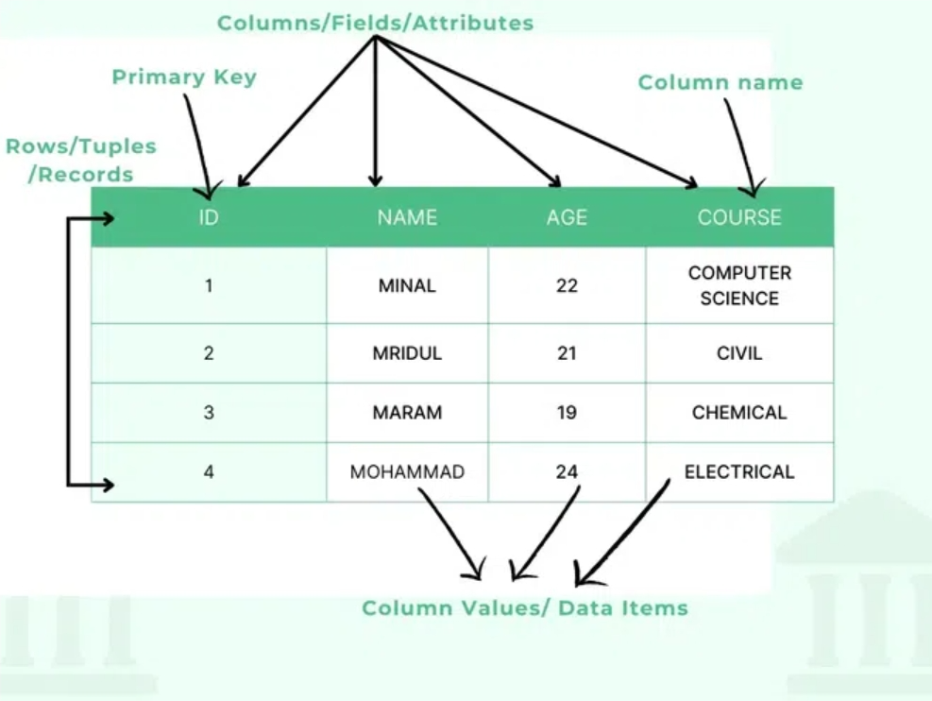

### Download PostgreSql

**You can download PostgreSQL from the official website using the following link:**

[**Download PostgreSQL**](https://www.postgresql.org/download/)

**Simply choose your operating system and follow the installation instructions provided on the page.**

**Or, you can watch a step-by-step installation guide on YouTube by clicking** [**https://youtu.be/4qH-7w5LZsA?si=BDgkgqJwwwlY3eUC**](https://youtu.be/4qH-7w5LZsA?si=BDgkgqJwwwlY3eUC) **this link.**